eRCP Detailed Design Document
Version 3.0.2
January 19, 2010

Technica Corporation
45245 Business Court, Suite 300
Dulles, VA 20166
703.662.2000 phone
703.662.2001 fax
www.technicacorp.com

Table of Contents
Abstract 1
1 Introduction 1
1.1 Regular Expression Implementation 2
1.2 Implementing Snort Rules on eRCP 3
1.2.1 The Flexibility of eRCP 3
1.2.2 Decomposition of Sample Snort Rule 3
2 Objectives and Requirements 4
3 Instruction Semantics 5
4 Sample Boot Program 6
5 Module Functional Description 9
5.1 eRCP Top-Level Description 9
5.1.1 eRCP Ports 10
5.1.2 Instantiated Components 11
5.2 Data Unit 11
5.2.1 Ports of Data Unit 12
5.2.2 Instantiated Components 14
5.2.2.1 Logic Unit 15
5.2.2.2 Target Data RAM 16
5.2.2.3 Source RAM 16
5.2.2.4 Action Data RAM 17
5.2.2.5 Operand Data RAM 17
5.2.2.6 Data Stack 18
5.2.2.7 LU Pointer Stack 18
5.2.2.8 Frame Router 19
5.2.2.9 Frame Bus 20
5.2.2.10 Boot ROM 21
5.2.2.11 Alert Engine 22
5.2.2.12 LU Count 24
5.2.2.13 Multiplexer 24
5.2.2.14 Target Shift Register 25
5.3 Control Unit 26
6 Summary 34
7 Acronym List 35
Appendix A: eRCP Parameterization 36

List of Figures
Figure 1. High-Level eRCP Diagram 1
Figure 2. Regular Expressions 2
Figure 3. Contents of Data Stack 6
Figure 4. eRCP Model Hierarchy 9
Figure 5. eRCP Top-Level Signal Description 10
Figure 6. Structural Description of Data Unit 12
Figure 7. Logic Unit Description 15
Figure 8. Target Data RAM Entity Description 16
Figure 9. Source Data RAM Entity Description 16
Figure 10. Action Data RAM Entity Description 17
Figure 11. Operand Data RAM Entity Description 17
Figure 12. Data Stack Entity Description 18
Figure 13. LU Pointer Stack Entity Description 19
Figure 14. Frame Router 20
Figure 15. Frame Bus 21
Figure 16. Boot ROM 22
Figure 17. Alert Engine 23
Figure 18. Representation of Combined Regular Expressions 23
Figure 19. Representation of Complex Regular Expressions 24
Figure 20. LU Count 24
Figure 21. Multiplexer 25
Figure 22. Target Shift Register 26
Figure 23. Control Unit 26
Figure 24. Control Unit State Diagram Pt. 0 27
Figure 25. Control Unit State Diagram Pt. 1 28
Figure 26. Control Unit State Diagram Pt. 2 29
Figure 27. Control Unit State Diagram Pt. 3 30
Figure 28. Control Unit State Diagram Pt. 4 31
Figure 29. Control Unit State Diagram Pt. 5 32
Figure 30. Control Unit State Diagram Pt. 6 33
Figure 31. Control Unit State Diagram Pt. 7 34
Figure 32. Control Unit State Diagram Pt. 8 34

List of Tables
Table 1. Regular Expression Composition 2
Table 2. eRCP Instruction Set 5
Table 3. Contents of Boot ROM 6
Table 4. Top-Level Ports 10
Table 5. Data Unit Ports 13
Table 6. Logic Unit Operation 15
Table 7. List of Possible Actions 17
Table 1. Semantic Switch Constants 36
Table 2. Vector Width Constants 37

Abstract
As a part of the Wizardry Project, the design objective is to create a processor that is capable of searching for matches to Regular Expressions, which is called the Enhanced Reconfigurable Content Processor (eRCP). The eRCP is presented as a tool to aid in the detection of network intrusion.

Introduction
Technica Corporation is working on a new prototype called Wizardry-Dynamically Reconfigurable System-On-Chip (Wizardry), an intelligence system that will be used to enhance control of data traversing a network. The Wizardry design is unique in that it allows single chips containing embedded cores executing software and classical hardware in an integrated circuit that implements the functions of a complete electronic system. The eRCP is a processor designed as a component of the Wizardry to perform the task of inspecting incoming preparsed Ethernet frames for matches to Regular Expressions.
The eRCP comprises two main units: Control Unit and Data Unit. The Control Unit is the brain of the eRCP, orchestrating every process in the eRCP. The Data Unit operates on incoming Ethernet frames, inspecting them for matches to Regular Expressions that were loaded through the Control Unit. Figure 1 illustrates the flow of data to and from the eRCP.
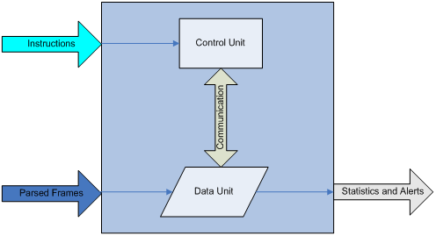
Figure 1. High-Level eRCP Diagram
Using a 9-bit instruction set, Regular Expressions are loaded and removed through the Instruction Interface. The eRCP can be booted with a predetermined set of Regular Expressions; it can also be loaded or unloaded interactively through the Instruction Interface. Target data, as well as a relational operation to a specific target, are loaded through the Instruction Interface. Action data, the action taken when a match is found, is also loaded through the Instruction Interface.
The Ethernet Frame Stream ports connect exclusively to the Data Unit. The eRCP inspects incoming frames for matches to Regular Expressions stored in memory. When matches are found to an expression, an alert signal is generated indicating the expression matched, frame location, and action to be taken. In addition, statistics regarding matches and resources are available from the Data Unit.

Regular Expression Implementation
Regular Expressions in the context of this paper take three distinct forms: Simple, Combined, and Complex Regular Expressions. Figure 2 illustrates the relationship between these forms.
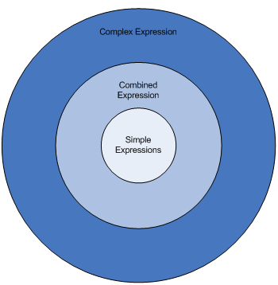
Figure 2. Regular Expressions
Simple Regular Expressions are at the heart of all expressions. Combined Regular Expressions are composed of a set of Simple Regular Expressions, while Complex Regular Expressions are composed of a subset of Combined Regular Expressions. Table 1 delineates each Regular Expression, indicating the composition and providing several examples.
Table 1. Regular Expression Composition
Expression Type | Composition | Example
Simple Expression | N/A | A <= B
 |  | C >= D
 |  | E = F
 |  | G != H
Combined Expression | Two or More Simple Expressions | ( A <= B ) OR ( C >= D )
 |  | ( E = F ) AND ( G != H )
 |  | ( A <= B ) OR ( C >= D ) OR ( E = F ) OR ( G != H )
Complex Expression | Two or More Combined Expressions | (( A <= B ) OR ( C >= D )) OR (( E = F ) AND ( G != H ))
 |  | (( A <= B ) OR ( C >= D )) AND (( E = F ) AND ( G != H ))
From this point forward, the term Regular Expression is synonymous with Simple Regular Expression, Combined Regular Expression, and Complex Regular Expression. In some cases, however, the former terms may be used if additional specification is needed.

Implementing Snort Rules on eRCP
Many Snort Rules can be implemented using the eRCP. This processor is currently limited to packet inspection; therefore, some features of Snort cannot be implemented. These unsupported features relate to packet modification. A brief statement about the flexibility of the eRCP is provided, as well as an illustrative example of a Snort Rule implemented using the eRCP.

The Flexibility of eRCP
The eRCP’s effectiveness is highly dependant on the creativity and intuition of the user. This system inherently requires the user to decompose any given Snort Rule into smaller, simpler expressions. An example of a Snort rule is: Match an Internet Control Message Passing (ICMP) packet from any source network to the 172.63.100.x network if the Data Size (dsize) is zero and the ICMP Type (itype) is 8.
Decomposition requires the completion of the following five key steps:
- Pinpoint all targets values, including the value that the parsed frame compares against.
- Identify all sources, including the portion of frame to be inspected.
- Extract all operands, including the equal, not equal, less than, or greater than symbols.
- Create a set Simple Regular Expression from information gathered.
- Eliminate a Simple Regular Expression that always results in a true output (if A = anything).
Sections 5.1.1 and 5.1.1.1 provide a detailed description of the sample Snort rules in the context of decomposition.

Decomposition of Sample Snort Rule
In this sample, there are four key pieces of information, which include ICMP, 172.63.100.x, 0, and 8. These four pieces of information are Target Data.
Additional information that can be extracted from this rule include: type, from any source, data size (dsize), and ICMP type (itype). The information serves as the source, or more specifically, the Frame Buffer where the data is stored that is inspected against the targets. Enough information has been gathered to create a set of Simple Regular Expressions to represent the Snort Rule.
To create Simple Regular Expressions, the following format of some source = some target should be followed. The following are the Simple Regular Expression extracted from Snort Rule Sample 1:
- Type = ICMP
- Source = any
- Destination = 172.63.100.xxx
- dsize = 0
- itype = 8
Next, identify any subrules that may be unnecessary. Simple Regular Expression 2 should be considered unnecessary, because it will always be true. The user has the choice of keeping it as part of the Snort Rule; however, in the interest of resources, it may be a good idea to remove this rule.
With each Simple Regular Expression derived and unnecessary ones removed, each Simple Regular Expression may now be loaded into the eRCP through the Instruction Interface, or stored in the Boot ROM.
After each Regular Expression is loaded, the Make Combined Expression instruction must be executed to finalize the Regular Expression.

Objectives and Requirements
Technica Corporation is working on a new prototype, an intelligence system that will be used to enhance control of data traversing a network. This system, called Wizardry, has several design requirements listed below:
- Take advantage of open intellectual property
- Fit on the ML40x evaluation board
- Support Internet Protocol Version 4 (IPv4) and Internet Version 6 (IPv6)
- Be able to inspect “all” packets arriving from a network, such as the following:
Support 1 Gigabits Per Second (Gb/s) line rate
Provide Tap-Monitoring to passively monitor network traffic
Provide In-Band Monitoring block or alter data
- Support Statistics Collection, includes the following:
Number of packets
Protocol types, such as initial protocols: Ethernet, IP, Transmission Control Protocol (TCP), User Datagram Protocol (UDP), File Transfer Protocol (FTP), Telnet, and Multi-Protocol Label Switching (MPLS)
Number of rules
- Generate alarms based on rule set match
The eRCP will be a subcomponent of the Wizardry Architecture that is responsible for inspecting frames for matches to a set of Regular Expressions. As a part of the Wizardry Project, the eRCP specific objectives and requirements are established and listed below:
- Device usage is less than 50 percent
- Device is dynamically Reconfigurable
- Allows users to enter Regular Expressions in accordance with the POSIX Regular Expression lexicon, including:
Support of relational operations including:
- =
- !=
- <
- >
- <=
- >=
Capability of searching for "don’t care" bytes
- Provides signals at the top level that, when a match to an expression has been found, the following is indicated:
Which expression was matched
Prescribed action to be taken
Frame location where match was found
- Provides method for entering myriad expressions, along with a prescribed action to be taken when a match is found to that expression
- Capable of searching for matches to Regular Expression given data input at a rate in excess of 10 Gbp/s
- Provides statistics about match count
- Provides statistics about the current state of the system, including Total Simple Expressions, Total Combined Expressions, and Total Complex Expressions
- Has maximum clock frequency

Instruction Semantics
The eRCP’s instruction set is very simple, consisting of only nine instructions. Each instruction is 9-bits wide. Table 2 describes each instruction in detail.
Table 2. eRCP Instruction Set
Name | Instruction | Description
Load Simple Expression | 100000001 | Loads next available Logical Unit
Load Simple Expression Direct | 100000010 | Loads specific Logic Unit
Make Combined Expression | 100000100 | Creates Combined Expression from Simple Expressions
Make Complex Expression | 100001000 | Creates Complex Expression from Combined Expressions
Remove Simple Expression | 100010000 | Unloads Specific Simple Expression
Remove Combined Expression | 100100000 | Unloads Specific Combined Expression
Remove Complex Expression | 101000000 | Unloads Specific Complex Expression
Clear All Expressions | 110000000 | Unloads all expressions
Load Vector | 0XXXXXXXX | Loads 8-bit vector(7 downto 0)
The eRCP’s instruction set is used to load Regular Expressions. Section 4 provides a description of a sample boot program, illustrating the use of the instruction set to load Regular Expressions.

Sample Boot Program
This sample program consists of eight separate instructions, which are listed in Table 3.
Table 3. Contents of Boot ROM
Address | Instruction | Description
H”00” | 000000000 | Loads “00000000” (4th byte of Target Data)
H”01” | 010000000 | Loads “10000000” (3rd byte of Target Data)
H”02” | 000000000 | Loads “00000000” (2nd byte of Target Data)
H”03” | 011110011 | Loads “11110011” (1st byte of Target Data)
H”04” | 000000000 | Loads “00000000” (Source Data)
H”05” | 000000000 | Loads “00000000” (Operand Data)
H”06” | 000000000 | Loads “00000000” (Action Data)
H”07” | 100000001 | Triggers Control Unit to perform “Load Simple Expression”
Loaded vectors are stored on the Data Stack located in the Data Unit. Figure 3 illustrates the Data Stack after the execution of the seventh load instruction.
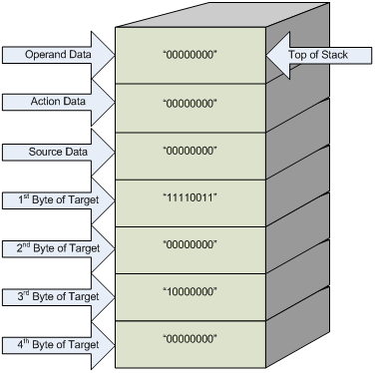
Figure 3. Contents of Data Stack
Load Simple Expression instruction is read by the Control Unit, with all necessary data stored on the Data Stack. The Control Unit then orchestrates the loading of the expression by storing operand, action, source, and target data in the appropriate Random Access Memories (RAMs) in the Data Unit.
Each instruction, with the exception of Load Vector and Clear All Expressions, requires certain values on the Data Stack prior to execution. The following list indicates the necessary data vectors to execute each instruction. Each vector must be loaded in the order shown, prior to loading the given instruction.
- Load Simple Expression
- Target byte 4
- Target byte 3
- Target byte 2
- Target byte 1
- Source
- Action
- Operand
- Load Simple Expression Direct
- Target byte 4
- Target byte 3
- Target byte 2
- Target byte 1
- Source
- Action
- Logic Unit LU Number
- Operand Data
- Make Combined Expression
- Simple Expression Number 1
- Simple Expression Number 2
- Simple Expression Number N
- Combine Type (AND or OR)
- Action
- Make Complex Expression
- Combined Expression Number 1
- Combined Expression Number 2
- Combined Expression Number N
- Combine Type (AND or OR)
- Action
- Remove Simple Expression
- Simple Expression Number 1
- Simple Expression Number 2
- Simple Expression Number N
- Remove Combined Expression
- Combined Expression Number 1
- Combined Expression Number 2
- Combined Expression Number N
- Remove Complex Expression
- Complex Expression Number 1
- Complex Expression Number 2
- Complex Expression Number N
Section 5 explicates the eRCP, beginning with a description of the top level of the eRCP.

Module Functional Description
This section provides a functional description of each module in the eRCP. A high-level description of each module is presented, identifying the overall function and purpose, as well as:
- A brief description of each port
- Identification of signals associated with each entity
- List of any additional components included
- Detailed functional description of each component
Figure 4 depicts the hierarchical design of the eRCP. It comprises two modules: Data Unit and Control Unit.
Figure 4. eRCP Model Hierarchy

eRCP Top-Level Description
This section describes the function of the eRCP from the highest level. The eRCP has several ports declared in its port declaration, which does not include reset and clock. The four port types include Instruction Interface, Ethernet Frame Stream, Statistical Interface, and Alert Interface. Instruction Interface ports are used to load and remove Regular Expressions. Ethernet Frame Stream ports accept incoming parsed Ethernet frames and allows each to be stored. The Statistics and Alert Interface ports notify the user of matches to loaded Regular Expressions, provides the frame location of those matches, and specifies the action to be taken while the Statistical Interface provides onboard resource statistics. The Ethernet Frame Stream, Statistical Interface, and Alert Interface ports connect exclusively to the Data Unit, while the Instruction Interface ports connect to the Control Unit and Data Unit.
Figure 5 depicts the top-level ports of the eRCP, illustrating the source and destination of all top-level signals.
Figure 5. eRCP Top-Level Signal Description

eRCP Ports
The eRCP has several ports at the top level. Table 4 provides a detailed description of each port, identifying port name, direction, bit width, and type.
Table 4. Top-Level Ports
Port Name | Direction | Bit Width | Port Type | Description
Instruction | IN | 9 | Instruction Interface | When bit eight is set to low, bits 7 through 0 are stored internally as an 8-bit vector. When bit eight is set to high, bits 7 through 0 are stored as an instruction.
Load_Instruction | IN | 1 | Instruction Interface | When set high, stores Instruction as either instruction or vector.
Busy | OUT | 1 | Instruction Interface | When set to high, instructions will not be stored in memory because processor is busy.
Field_Data | IN | 32 | Ethernet Frame Stream | Parsed Data vector of type Field_Type.
Field_Type | IN | 8 | Ethernet Frame Stream | Indicates which portion of the frame Field_Data is.
Data_Ready | IN | 1 | Ethernet Frame Stream | Signals that Field_Data is ready to be stored internally.
Available_LU | OUT | 6 | Statistics Interface | Indicates number of available Logic Units.
Available_CE | OUT | 5 | Statistics Interface | Specifies total number of vacant Combined Expressions.
Available_CmpE | OUT | 5 | Statistics Interface | Indicates how many Complex Expressions can be loaded.
Basic_Indicator | OUT | 50 | Alert Interface | Output value for each of the 50 Logic Units. The nth bit corresponds to the nth Logic Unit.
Combined_Indicator | OUT | 32 | Alert Interface | Output value for each Combined Expression. The nth bit corresponds to the nth Complex Expression.
Complex_Indicator | OUT | 32 | Alert Interface | Output value for each Complex Expression. The nth bit corresponds to the nth Complex Expression.
Frame_Indicator | OUT | 32 | Alert Interface | Identifies which frame is being inspected.

Instantiated Components
The following components are included in the top-level structural description of the eRCP:
- Data Unit
- Control Unit
A thorough explanation, provided in Section 5.2 and Section 5.3, describes the functionality of each component and the interdependence between the two modules.

Data Unit
This section describes the function and structure of the Data Unit. The Data Unit has several ports declared in its port declaration, which does not include reset and clock. The five port types include Control Unit Communication, Instruction Interface, Ethernet Frame Stream, Statistical Interface, and Alert Interface. Control Unit Communication ports provide information to the Control Unit from the Data Unit, and provide control signals to the Data Unit from the Control Unit. Instruction Interface ports allow literal data, such as target values, source data, operands, and action data, to be stored internally. Ethernet Frame Stream allows preparsed frames to be stored and inspected. Statistical Interface ports outputs information about available resource, such as available LUs, Combined Expressions, and Complex Expressions. Alert Interface ports directly provide the user with information about matches to Regular Expressions and specifies which action will be taken. Figure 6 depicts the connection of all components contained in the Data Unit.
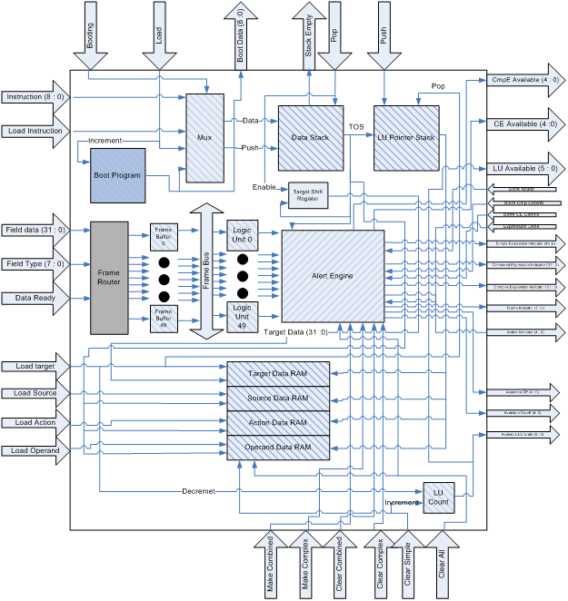
Figure 6. Structural Description of Data Unit

Ports of Data Unit
The Data Unit has many ports declared in the entity declaration. Table 5 provides a detailed description of each port, identifying the port name, direction, bit width, and type.

Table 5. Data Unit Ports
Port Name | Direction | Bit Width | Port Type | Description
Booting | IN | 1 | Control Unit Communication | Signal from Control Unit. When set to high, allows program stored in Boot Read Only Memory (ROM) to be executed.
Load | IN | 1 | Control Unit Communication | Loads current instruction stored in Boot ROM and increments Boot ROM address to next instruction on next cycle.
Boot Data | OUT | 9 | Control Unit Communication | Outputs instructions stored in Boot ROM to the Control Unit.
Stack Empty | OUT | 1 | Control Unit Communication | Indicates that the Data Stack is empty. Used as an input to Control Unit.
Pop | IN | 1 | Control Unit Communication | Pops value on top of Data Stack.
Push | IN | 1 | Control Unit Communication | Pushes value on Data Stack to the LU Pointer Stack.
Load Target | IN | 1 | Control Unit Communication | Loads Target from Target Shift Register into Target RAM.
Load Source | IN | 1 | Control Unit Communication | Loads Source data from Data Stack to Source RAM.
Load Action | IN | 1 | Control Unit Communication | Loads Action data from Data Stack to Action RAM.
Load Operand | IN | 1 | Control Unit Communication | Loads Operand data from Data Stack to Operand RAM
Make Combined | IN | 1 | Control Unit Communication | Creates Combined Expression in Alert Engine.
Make Complex | IN | 1 | Control Unit Communication | Creates Complex Expression in Alert Engine.
Clear Combined | IN | 1 | Control Unit Communication | Clears Combined Expression in Alert Engine.
Clear Complex | IN | 1 | Control Unit Communication | Clears Complex Expression in Alert Engine.
Clear All | IN | 1 | Control Unit Communication | Clears all LUs, Combined Expressions, and Complex Expressions.
Store Action | IN | 1 | Control Unit Communication | Stores action associated with Combined or Complex Regular Expression.
Store CE Contrib | IN | 1 | Control Unit Communication | Stores contribution associated with Combined Regular Expression.
Store Cmp Contrib | IN | 1 | Control Unit Communication | Stores contribution associated with Complex Regular Expression.
Expression Done | IN | 1 | Control Unit Communication | Signal to Alert Engine indicating that expression is complete.
Instruction | IN | 9 | Instruction Interface | Contains 8-bit vector data (Instruction (7 downto 0)) to be pushed onto the Data Stack.
Load Instruction | IN | 1 | Instruction Interface | When set to high, pushes 8-bit vector onto Data Stack.
Field Data | IN | 32 | Ethernet Frame Stream | Data to be stored and inspected in Data Unit.
Field Type | IN | 8 | Ethernet Frame Stream | Indicates portion of frame represented by Field Data.
Data Ready | IN | 1 | Ethernet Frame Stream | Enables Field Data to be stored in Data Unit.
Port Name | Direction | Bit Width | Port Type | Description
Avaliable LU | OUT | 6 | Statistical Interface | Indicates number of available LU in Data Unit.
Available CE | OUT | 5 | Statistical Interface | Indicates number of available Combined Expressions in Alert Engine.
Available CmpE | OUT | 5 | Statistical Interface | Indicates number of Complex Expressions in Alert Engine.
Simple Expression Indicator | OUT | 50 | Alert Interface | Indicates the output of each LU.
Combined Expression Indicator | OUT | 32 | Alert Interface | Indicates the output of each Combined Expression.
Complex Expression Indicator | OUT | 32 | Alert Interface | Indicates the output of each Complex Expression.
Frame Indicator | OUT | 8 | Alert Interface | Indicates frame that is being inspected.
Action Indicator | OUT | 5 | Alert Interface | Indicates action to be taken.
In Table 5, ports that are only 1-bit wide are control signals.

Instantiated Components
As depicted in Figure 6, the Data Unit is a collection of many subcomponents. The instantiated components include the following:
- Logic Unit
- Target Data RAM
- Source Data RAM
- Action Data RAM
- Operand Data RAM
- Data Stack
- LU Pointer Stack
- Frame Buffer
- Frame Router
- Frame Bus
- Boot ROM
- Alert Engine
- LU Count
- Multiplexer
- Target Shift Register
The following subsections provide a detailed explanation of each subcomponent.

Logic Unit
The Logic Unit (LU) is the primary component in the Data Unit performing inspection of the parsed Ethernet Frames. Each LU is accompanied by a unique set of Target, Source, Operand, and Action RAMs. The Target RAM output is hardwired to the Target port, while the Operand RAM output is hardwired to the Operand port. The LU compares the parsed Ethernet frames against values stored in the Target RAM and performs the relational operation stored in the Operand RAM. Figure 7 illustrates the ports associated with the Logic Unit.
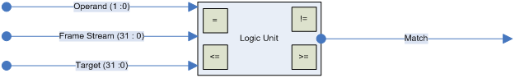
Figure 7. Logic Unit Description
The LU is capable of performing the following relational operations:
- Equality (=)
- Inequality (!=)
- Less than or Equal (<=)
- Greater than or Equal (>=)
The Operand specifies which relational operator the LU is currently performing. Table 6 lists the operations the LU performs, indicating the Operand value for each.
Table 6. Logic Unit Operation
Operation | Corresponding Operand Value | Description
Equality | “00” | If Frame Stream is equivalent to Target then Match = ‘1’, otherwise Match = ’0’.
Inequality | “01” | If Frame Stream is not equivalent to Target then Match = ‘1’, otherwise Match = ’0’.
Less Than or Equal | “10” | If Frame Stream is less than or equal to Target then Match = ‘1’, otherwise Match = ’0’.
Greater Than or Equal | “11” | f Frame Stream is greater than or equal to Target then Match = ‘1’, otherwise Match = ’0’.
The LU can also inspect for equality with “don’t care” bytes in the four-byte target data. For example, given a target value of H“UUUUUU00,” the LU is able to interpret the three uninitialized bytes as “don’t care.” This feature provides additional flexibility in the inspection process.

Target Data RAM
The Target Data RAM is a 32-bit wide memory element that stores the target value for a Logic Unit. Each Logic Unit has its own unique Target Data RAM. Incoming parsed Ethernet Frames are inspected against the target value stored in this entity. Figure 8 illustrates the ports of the Target Data RAM.
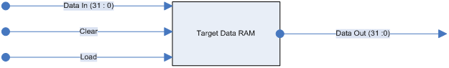
Figure 8. Target Data RAM Entity Description
The Control Unit orchestrates all data loading and clearing. When the Control Unit asserts Load, target data is loaded through the Data In port. When the Control Unit asserts Clear, the value stored in this entity resets. Data Out indicates the value stored.
The Target Data RAM cannot be loaded directly with data from the Data Stack due to the width of the target. The Data Stack is eight bits wide, while the target data is thirty-two bits. Therefore, Data is loaded from the Target Shift Register, rather than directly from the Data Stack. Refer to Section 5.2.2.14 for details about the Target Shift Register.

Source RAM
The Source RAM is a 6-bit wide memory element that stores the source value for a Logic Unit. Each Logic Unit has an exclusive Source RAM hardwired to the respective Frame Bus select signal, indicating which portion of the parsed Ethernet frame is inspected. Figure 9 depicts the ports of the Source Data RAM.
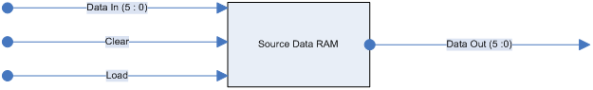
Figure 9. Source Data RAM Entity Description
The Control Unit orchestrates all data loading and clearing. When the Control Unit asserts Load, Source Data is loaded through the Data In port.
Data In is hardwired to the TOS port on the Data Stack, allowing Source Data to store directly from the top of the Data Stack. Data Out is connected directly to the Frame Bus and indicates which Frame Buffer is streamed to the Logic Unit for inspection.

Action Data RAM
The Action Data RAM is a 5-bit wide memory element that stores the action value for a Logic Unit. Each Logic Unit has an exclusive Action RAM indicating which action will be taken upon a match. Figure 10 depicts the ports of the Action Data RAM.
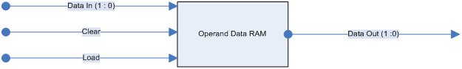
Figure 10. Action Data RAM Entity Description
The Control Unit orchestrates all data loading and clearing. When the Control Unit asserts Load, Action Data is loaded through the Data In port.
Data In is hardwired to the TOS port on the Data Stack, allowing Action Data to store directly from the top of the Data Stack. Data Out connects directly to the Alert Engine and indicates which action will be output from the Alert Engine when a match is found. Table 7 provides the actions that are currently supported by the eRCP.
Table 7. List of Possible Actions
Action | Hex Value | Description
Alert | H’00 | Sets flag
Log | H’01 | Logs the frame
Activate | H’02 | Activate dynamic rule
Dynamic | H’03 | Loads dynamic rule
Increment | H’04 | Increments counter

Operand Data RAM
The Operand Data RAM is a 2-bit wide memory element that stores the operand value for a Logic Unit. Each Logic Unit has an exclusive Operand RAM indicating which relational operation the Logic Unit is performing. Figure 11 depicts the ports of the Operand Data RAM.
Figure 11. Operand Data RAM Entity Description
The Control Unit orchestrates all data loading and clearing. When the Control Unit asserts Load, Operand Data is loaded through the Data In port.
Data In is hardwired to the TOS port on the Data Stack, allowing Operand Data to store directly from the top of the Data Stack. Data Out connects directly to the Operand port of the Logic Unit and indicates which relational operation the LU performs.

Data Stack
The Data Stack stores the eight-bit vectors that are loaded through the Instruction Interface and Boot ROM. As a last-in-first-out data structure, each eight-bit vector is stored by pushing it onto the stack. To access the next value on the stack, the value at the top of stack is popped from the top of the stack. Data Stack can accommodate a maximum of 64 vectors. Figure 12 illustrates the ports of the Data Stack.
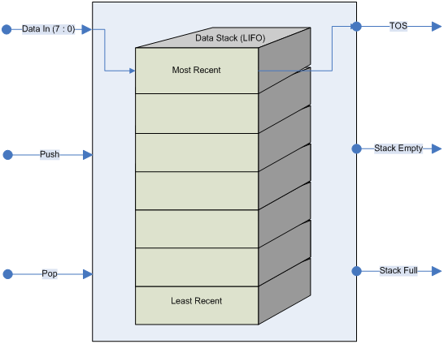
Figure 12. Data Stack Entity Description
Push connects to the Load Instruction port of the Data Unit. However, data can only push to the stack when the ninth bit of the instruction is zero, such as when the Load Vector instruction executes. Pop is driven from the Control Unit, while Stack Empty and Stack Full are inputs to the Control Unit. TOS outputs the most recent vectors stored.

LU Pointer Stack
The LU Pointer Stack contains the index value of the next LUs to be loaded. Figure 13 illustrates the initial contents and ports of the LU Pointer Stack.
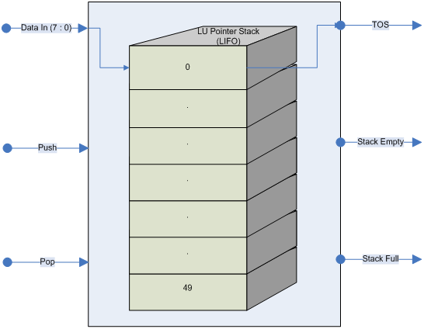
Figure 13. LU Pointer Stack Entity Description
Upon startup, the LU Pointer Stack is initialized as illustrated in Figure 13. Hence, the first LU to be loaded is the 0th LU. The Pop port directly connects to the Load Target signal from the Control Unit. When the Control Unit sets the Load Target to logic high, such as when Pop is set to high, the value stored at the top of the stack is popped off.
The Push port directly connects to the Push port in the Data Unit and is only set by the Control Unit when the Load Simple Expression Direct instruction is used. The LU number is pushed to the top of the stack, allowing the specified LU number to be loaded directly. Any LU can be loaded directly, even if it has already been loaded. Valid values for the LU number are zero through forty-nine.

Frame Router
This entity is responsible for storing incoming parsed Ethernet frames into individual buffers. Incoming parsed frames are stored based upon the value of Field Type. Figure 14 illustrates the ports of the Frame Router.
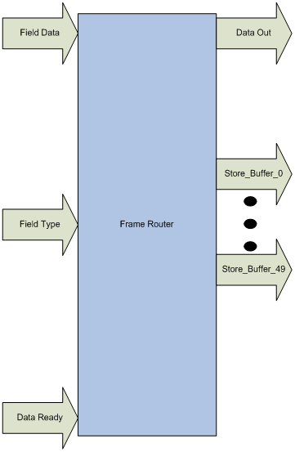
Figure 14. Frame Router
Field Data is routed to the Data Out port. The Data Out port connects to the Data In port of each Frame Buffer. Store_Buffer_n, referring to Store_Buffer_0 through Store_Buffer_49, is connected to the Load port of the nth Frame Buffer. When parsed Ethernet frame data is ready to be processed, the Store_Buffer_n signal corresponding to the Field Type is enabled. Field_Type specifies which portion of the frame is received. For example, if the field type is zero, Store_Buffer_0 enables when Data Ready sets to high, thus storing the parsed Ethernet frame portion in the appropriate buffer.

Frame Bus
The Frame Bus is responsible for making the contents of a Frame Buffer available to any given LU, as specified by the Source Data RAM. When the user programs a Simple Regular Expression into the eRCP, this entity has the task of making sure that the appropriate Frame Buffer connects to the LU. Figure 15 illustrates the ports of the Frame Bus.
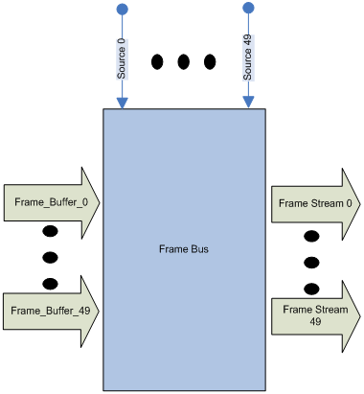
Figure 15. Frame Bus
Each LU’s respective Source Data RAM’s Data Out port is hardwired to the Source N input of Frame Bus. The value stored in this RAM is used to select one of the fifty frame buffers. This enables any LU to inspect any portion of the parsed Ethernet frame stored in the Frame Buffers.

Boot ROM
The Boot ROM entity contains a set of instructions that are executed after startup. The instructions stored in this memory element initialize the eRCP with a set of Regular Expressions.
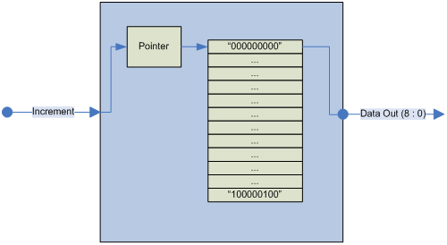
Figure 16. Boot ROM
The Boot ROM can accommodate up to 64 instructions. The Increment is connected to the Load port of the Data Unit and is driven by the Control Unit. Data Out is hardwired to the Boot Instruction port of the Data Unit and to the input of the Multiplexer. Refer to Section 4 for an example boot program.

Alert Engine
The Alert Engine is responsible for creating and storing Combined and Complex Regular Expressions. This entity has several inputs and outputs, as illustrated in Figure 17. Inputs include each LU’s output signal; each LU’s associated action, such as the output from each Action Data RAM; as well as signals from the Control Unit and the top of the Data Stack.
The Alert Engine can have up to 32 Combined Regular Expressions, and up to 32 Complex Regular Expressions loaded. However, support for additional Combined and Complex Expressions may be added during the implementation phase if device usage allows.
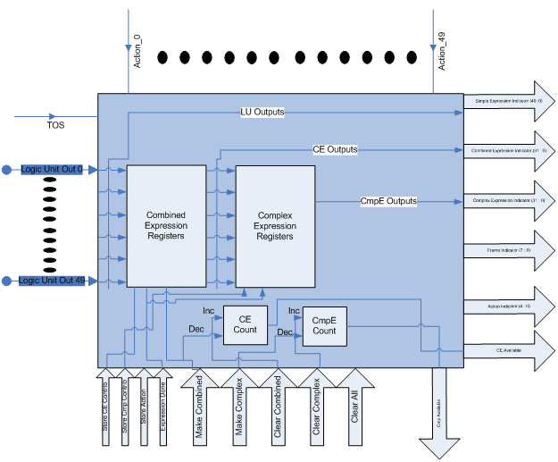
Figure 17. Alert Engine
Each combined Regular Expression has a 49-bit register inside of the Action Engine that physically represents the Combined Expression.
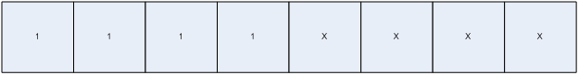
Figure 18. Representation of Combined Regular Expressions
Each bit in this register signifies what contribution each individual LU makes to the given Combined Expression. A zero indicates that the indexed comparator is to be ORed together, while one specifies AND. A separate process contained in the Action Engine performs the appropriate ANDing or ORing based upon the content of these registers. Figure 18 illustrates the logical representation of a Combined Expression. In this example, the LU’s zero through three are to be ANDed together, while the remaining LUs have no contribution to this expression. Consequently, when LUs zero through three are high, the output port Combined_Expression_n will be asserted by the Action Engine.
Similarly, each compex Regular Expression has a 32-bit register inside of the Action Engine that physically represents the Complex Expression.
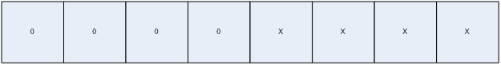
Figure 19. Representation of Complex Regular Expressions
Each bit in this register signifies what contribution each individual Combined Regular Expression makes to the given complex Regular Expression. A zero indicates that the indexed Combined Regular Expression is to be ORed together, while one specifies AND. A separate process contained in the Action Engine performs the appropriate ANDing or ORing based upon the content of these registers. Figure 19 illustrates the logical representation of a complex Regular Expression. In this example, combined Regular Expressions zero through three are to be ORed together, while the remaining expressions have no contribution to this expression. Consequently, if any one of Combined Regular Expressions zero through three are high, the output port Combined_Expression_n will be asserted by the Action Engine.

LU Count
This counter, LU Count, is initialized to 50, indicating that the system has a total of 50 Logic Units available upon startup. Figure 20 illustrates the ports of LU Count.
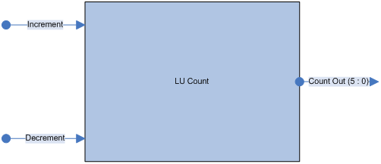
Figure 20. LU Count
The Increment port is hardwired to the Remove Simple Expression port of the Data Unit, while the Decrement port is hardwired to the Load Target port of the Data Unit. Therefore, the Control Unit sets the Increment and Decrement for the LU Count at the appropriate cycle.

Multiplexer
This multiplexer chooses to either multiplex the Boot ROM or Instruction Interface, and allows either to be executed. Figure 21 illustrates the ports of the Multiplexer.
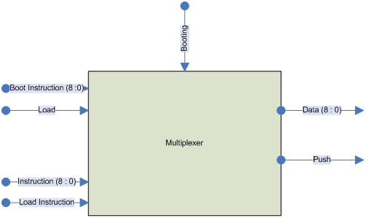
Figure 21. Multiplexer
Booting and Load are hardwired to the Data Unit ports of the same name and are driven by the Control Unit. Instruction and Load Instruction are also connected to the Instruction and Load Instruction ports of the Data Unit, but are driven from the top-level inputs of the same name. Boot Instruction is hardwired to the Output port of the Boot ROM. On the output side, Data and Push are both connected to the Data Stack.
When the Control Unit sets Booting to high, Boot Instruction and Load are multiplexed through to outputs Data and Push. Similarly, when the Control Unit clears Booting to low, Instruction and Load Instruction are multiplexed through to Data and Push.
This entity provides a mechanism for either loading a series of instructions from the Boot ROM, or loading a series of instructions interactively through the Instruction Interface.

Target Shift Register
The Target Shift Register assembles 8-bit Target Data into 32-bit Target Data. Figure 22 depicts the ports of Target Shift Register.
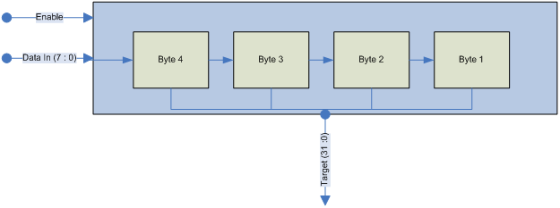
Figure 22. Target Shift Register
Enable is hardwired directly to the Pop port of the Data Unit and is driven by the Control Unit, while Data In connects to the top of the Data Stack. Target connects directly to the Target Data RAM.
Each time a value is popped from the Data Stack, Target Shift Register shifts in the popped value. This allows the Target Data RAM to store a 32-bit target value.

Control Unit
The Control Unit is the brain of the eRCP, orchestrating every process in the eRCP. This entity has several outputs, each controlling a specific operation in the Data Unit. The Data Unit provides the Control Unit with several feedback inputs that allow the Control Unit to make decisions about what will happen next. Figure 23 illustrates the input and output ports of the Control Unit.
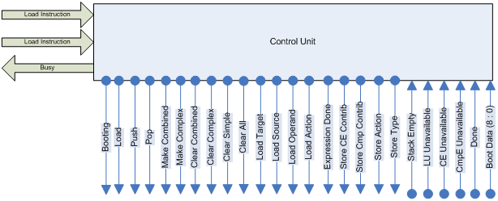
Figure 23. Control Unit
Each output from the Control Unit to the Data Unit triggers a specific consequence in the Data Unit. Refer to Table 5. Data Unit Ports, for further explanation of the output signals from the Control Unit to the Data Unit.
The Control Unit is a finite state machine that drives the Data Unit in such a way that the following will occur:
- Data is loaded, stored, and removed at the appropriate locations within the Data Unit
- Instructions are executed, resulting in the desired functionality specified in the Boot ROM or interactively loaded through the Instruction Interface
Figures 24 through 31 illustrate the decisionmaking process and subsequent orchestration of the Data Unit.
Output ports listed in circular states indicate that those outputs are set high in that given state, while all other unlisted output ports are low.

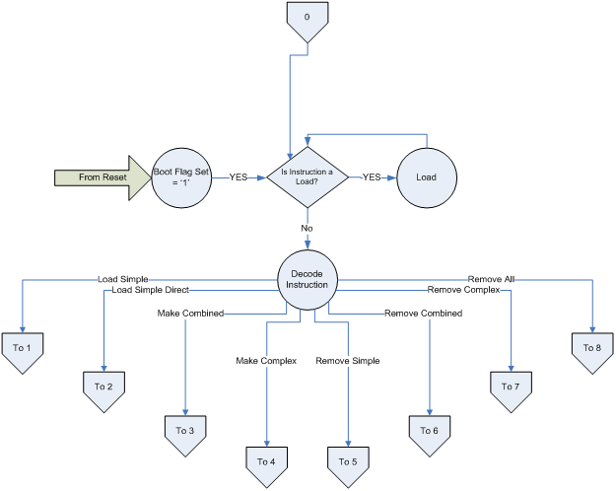
Figure 24. Control Unit State Diagram Pt. 0
Figure 25. Control Unit State Diagram Pt. 1
Figure 26. Control Unit State Diagram Pt. 2
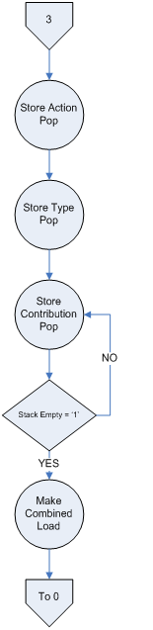
Figure 27. Control Unit State Diagram Pt. 3
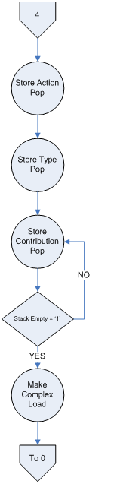
Figure 28. Control Unit State Diagram Pt. 4
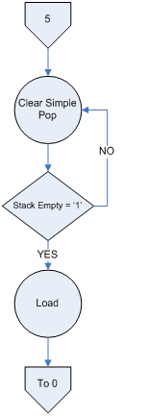
Figure 29. Control Unit State Diagram Pt. 5
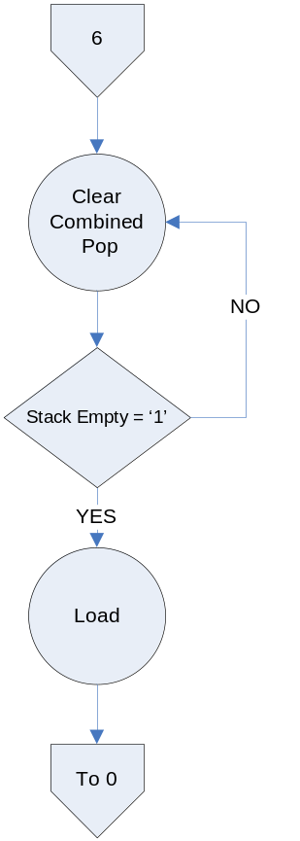
Figure 30. Control Unit State Diagram Pt. 6

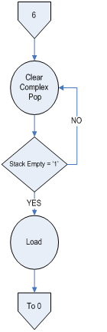
Figure 31. Control Unit State Diagram Pt. 7
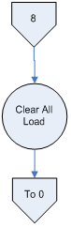
Figure 32. Control Unit State Diagram Pt. 8

Summary
The eRCP is designed to inspect incoming pre-parsed Ethernet frames for matches to Regular Expressions. Using a 9-bit instruction set, Regular Expressions are loaded and removed through the Instruction Interface, but can also be loaded serially through a Boot ROM. When matches are found to Regular Expressions, the eRCP generates an alert, indicating the expression matched against, the specified action to be taken, and the frame of the match. System statistics are also available to provide information about the state of the processor.
Since the eRCP can be boot with a predetermined set of Regular Expressions and loaded or unloaded interactively through the Instruction Interface, the eRCP emerges as a critical module in the success of Wizardry.
This meets all of the specific design requirements enumerated above in section 2.0, providing a robust platform to allow maximum flexibility for frame inspection.

Acronym List
Acronym | Definition
CE | Combined Regular Expression
CmpE | Complex Regular Expression
FTP | File Transfer Protocol
ICMP | Internet Control Message Passing
IP | Internet Protocol
LU | Logic Unit
MPLS | Telnet, and Multi-Protocol Label Switching
POSIX | Portable Operating System Interface
RAM | Random Access Memories
ROM | Read Only Memory
TCP | Transmission Control Protocol
TOS | Top of Stack
UDP | User Datagram Protocol
Gb/s | Gigabits per Second

Appendix A: eRCP Parameterization
Introduction
Enhanced Reconfigurable Content Processor (eRCP) provides maximum flexibility and functionality to the user. Using a scalable architecture, modification of eRCP_constant.vhd provides the user with the ability to transform eRCP to meet a range of requirements. Area, speed, and performance can be significantly refined to achieve the desired functionality. Scaling eRCP enables its use under a wide variety of constraints.
eRCP Scaling
Constants set in eRCP_constants.vhd allow the instantiation of many configurations, design alternatives, and computational capabilities. The values assigned to these constants in Sections 2.1 and 2.2 indicate the recommended values set by default.
Semantic Switches
These constants directly affect the performance capabilities of eRCP. Table 1 delineates the purpose and function of the semantic switches in further detail.
Table 8. Semantic Switch Constants
Semantic Switch Constants | Description
CONSTANT num_of_LUs : integer := 31 | - Specifies the total number, N + 1, of Simple Expressions generated in the Data Unit.  - This value also defines the total number of Target, Source, Action, and Operand registers generated in the Data Unit.  - The maximum value for N is 63 in this version of eRCP.
CONSTANT num_of_CE : integer := 31 | - Specifies the total number, N + 1, of Combined Expressions generated in the Alert Engine.  - The maximum value for N is 31 in this version of eRCP.
CONSTANT num_of_CmpE : integer := 31 | - Specifies the total number, N + 1, of Complex Expressions generated in the Alert Engine.  - The maximum value for N is 31 in this version of eRCP.
CONSTANT num_of_boot_instructions : integer := 90 | - Specifies total number of instructions to be executed during the boot phase.  - This number should be equal to the number of instructions that the user intends to execute during boot phase; therefore, this constant may be set to 0 to bypass the boot process.  - The user has the option of booting the processor with as many or as few expressions as desired.
Vector Widths
These constants limit the vector sizes of key registers and data structures used by eRCP. Modification of these constraints may help to save Field Programmable Gate-Array (FPGA) space, or provide additional performance qualities. Refer to Table 2 for a description of the vector widths.
Table 9. Vector Width Constants
Vector Width Constants | Description
CONSTANT target_width : integer := 31 | - Defines the width of the target value that each Logic Unit searches.  - Current implementation only supports 32-bit target width.  - This value may be modified in conjunction with the Logic Unit Architecture to support larger target values.
CONSTANT source_ram_width : integer := 5 | - Defines the width of Source Registers generated in the Data Unit.  - EmPAC is currently limited to sixty-four field types; however, this constant can be changed, allowing more or less sources to be recognized.
CONSTANT action_ram_width : integer := 4 | - Defines the width of Action Registers generated in the Data Unit.  - More actions may be added to the design by increasing this value.
CONSTANT operand_ram_width : integer := 5 | - Defines the width of Operand Registers generated in the Data Unit.  - Additional operations may be added by increasing this value; however, this value should never be less than 5.
CONSTANT data_stack_depth : integer := 16 | - Specifies the depth of the Data Stack contained in the Data Unit.  - This depth may be modified; however, the value should never be less that 8. This is due to the fact the instruction requiring the most space, Load Simple Direct, needs 8 vectors on the Data Stack to execute properly.  - Refer to the eRCP Detailed Design Document for more information.
CONSTANT LU_pointer_stack_depth : integer := 64; | - Specifies the depth of the Logic Unit Stack contained in the Data Unit.  - This value should be equal to the number of Simple Expressions per given implementation.
CONSTANT CE_pointer_stack_depth : integer := 32 | - Specifies the depth of the Combined Expression Pointer Stack contained in the Alert Engine.  - This value should be equal to the number of Combined Expressions per given implementation.
CONSTANT CmpE_pointer_stack_depth : integer := 32 | - Specifies the depth of the Complex Expression Pointer Stack contained in the Alert Engine.  - This value should be equal to the number of Complex Expressions per given implementation.
CONSTANT boot_rom_addr_width : integer := 8 | - Defines the address width of the Boot ROM.  - The recommended width allows a maximum of 256 instructions to be stored in the Boot ROM.  - This value can be decreased to save FPGA space or increased to provide additional preloaded expressions.
CONSTANT instruction_width : integer := 9 | - Defines width of instruction set.  - This constant may be increased to expand the instruction set in the future; however, it is recommended that this constant remain 9.

